
SVKM’s NMIMS
School of Technology Management & Engineering,
Mumbai Campus

Year:-5TH | Program:- B. Tech Integrated | Semester:- IX

Subject:- Mobile Application Development
Subject Code:-702AI0E002
Mini Project Title
Weather Information App ( Skycast)
Team Details
Pranav Padiyar – C138
Adnan Shah – C144
Aditya Sarkar – C152
Aryan Kakadia – C153

Bachelor of Technology (Computer Engineering)
Fifth Year, Semester IX
Faculty: Prof Aishwarinandini Bishnu
AY 2026-27

INDEX
Sr. No. | Topic | Page No.
1 | Introduction | 3-4
2 | System Analysis | 4-6
3 | System Requirements | 7-8
4 | Dataset Collection and Preprocessing | 8-9
7 | Results and Discussion | 10-26
8 | Conclusion and Future Scope | 27

CHAPTER 1: INTRODUCTION
1.1 Introduction to the Project
In recent years, unpredictable weather patterns and micro-climate fluctuations have made real-time environmental monitoring essential for daily commute planning, outdoor activity scheduling, and disaster readiness. SkyCast (com.example.madminiproject_weatherapp) is a feature-rich, cross-platform Android mobile application developed in Java using modern Android Software Development Kit (SDK) standards and Cloud Infrastructure.
SkyCast integrates real-time meteorological data through RESTful web services via OpenWeatherMap API, location resolution through Google Geocoder and Google Maps SDK, cloud profile persistence using Firebase Authentication and Cloud Firestore, on-device Voice Synthesis (Text-to-Speech) and Speech Recognition, dynamic temperature unit conversion, dynamic 7-day extended forecast generation, and interactive radar map visualization via Android WebView.

1.2 Problem Statement
Traditional weather applications often suffer from several user-experience and technical limitations:
1.Static Location Dependencies: Many apps rely strictly on static city names or full GPS tracking, failing to resolve sub-regions (e.g., specific areas such as Vile Parle, Mumbai) or pinned map locations.
2.Lack of Accessibility: Text-heavy interfaces make it difficult for visually impaired users or drivers to quickly consume weather updates.
3.Absence of Intelligent Actionable Guidance: Raw numerical metrics (e.g., temperature in °C, humidity in %, pressure in hPa) leave users to interpret whether they need an umbrella, warm clothing, or heat protection.
4. Poor Offline & Cloud Integration: Lack of persistent cloud user profiles prevents users from maintaining customized preferences (such as favorite cities) across app sessions.

1.3 Objectives of the Project
The primary objectives of the SkyCast Weather Application are:
1. Real-time Meteorological Data Retrieval: Fetch temperature, feels-like temperature, humidity, wind speed, atmospheric pressure, and weather condition descriptions via HTTP RESTful APIs.
2. Hybrid Location Input & Resolution: Support manual search, address-to-coordinate Geocoding, Google Maps pin selection, and Voice Recognition.
3. AI Weather Advice Engine: Dynamically calculate and render actionable tips based on environmental conditions (e.g., rain, thunderstorms, extreme heat, or freeze).
4. Voice Synthesis (Text-to-Speech): Automatically read out weather summaries and advisory tips for improved accessibility.
5. Secure Authentication & Cloud Synchronization: Enable user sign-up/login via Firebase Authentication and store favorite location preferences in Cloud Firestore.
6. Severe Weather Alerting: Automatically scan incoming meteorologic data for hazards (thunderstorms, heavy rainfall, heatwaves) and trigger Material alert dialogs alongside broadcast notifications.

CHAPTER 2: SYSTEM ANALYSIS
2.1 Existing System
Existing weather applications primarily utilize standard HTTP requests to query weather data based solely on explicit city name input. They render basic static text fields showing current temperature and weather conditions without offering contextual advice or speech output.

2.2 Limitations of the Existing System
• Limited Multi-modal Interaction: Lack of integrated voice search and text-to-speech feedback.
• Rigid Location Queries: Inability to resolve specific localized neighborhood names to latitude and longitude coordinates.
• No Pin-on-Map Feature: Users cannot tap an interactive map to retrieve weather data for custom locations.
• No Cloud Preferences: User settings reset when the app process is destroyed.

2.3 Proposed System
The proposed SkyCast platform addresses these gaps through:
1. Multi-Input Weather Queries: Supports Text input, Google Maps Interactive Pinning, Voice Commands, and Geocoded addresses.
2. AI Advisory Recommendation: Algorithmic contextual advice based on live weather parameters.
3. Firebase Cloud Ecosystem: Secure Firebase Auth and Cloud Firestore backend for profile synchronization.
4. Accessibility First Design: Built-in TextToSpeech engine automatically vocalizes city weather conditions upon data retrieval.
5. Dynamic 7-Day Extended Forecast: RecyclerView with custom adapters (ForecastAdapter) to showcase week-long forecasts.

2.4 Feasibility Study
• Technical Feasibility: Developed using standard Java Android APIs, Firebase SDKs, and REST API integration over HTTPS, ensuring high system stability and reliability.
• Operational Feasibility: Intuitive Material Design interface requires zero user training. Voice interaction simplifies operation while driving or multitasking.
• Economic Feasibility: Built entirely using open-source tools (Android Studio), free-tier cloud infrastructure (Firebase Spark Plan), and public REST APIs (OpenWeatherMap free tier).

2.5 Functional Requirements
1. User Authentication: Sign-up, Sign-in, and Logout using Firebase Auth.
2. Profile Management: Fetch user details and update "Favorite City" in Cloud Firestore.
3. Weather Search & Geocoding: Search weather by city name, area (via Geocoder), or latitude/longitude coordinates.
4. Voice Interaction: Speech-to-text input (RecognizerIntent) and text-to-speech summary readout (TextToSpeech).
5. Interactive Map Pinning: Tap Google Maps location in MapActivity to receive weather data for specific coordinates.
6.Temperature Conversion: Toggle dynamically between Celsius (°C) and Fahrenheit (°F).
7. Weather Radar WebView: View real-time precipitation/clouds map via WeatherWebViewActivity.
8. Severe Weather Scanner: Automatic detection and alert popup for thunderstorms, floods, blizzards, and heatwaves.

2.6 Non-Functional Requirements
1. Performance: API requests process in background threads (Thread / runOnUiThread) to prevent UI lockup.
2. Usability: Responsive layout using ConstraintLayout and Material Design 3 guidelines.
3. Security: Secure user password storage via Firebase Auth encryption and HTTPS API calls.
4. Reliability: Graceful exception handling for unresolvable location names or missing internet connection.

CHAPTER 3: SYSTEM REQUIREMENTS
3.1 Hardware Requirements
◦ Processor: Intel Core i5 / AMD Ryzen 5 or higher (64-bit).
◦ RAM: Minimum 8 GB (16 GB recommended for Android Emulator).
◦ Storage: 20 GB available SSD space.
• Testing Device (Physical / Emulator):
◦ Processor: ARM64 or x86_64 Architecture.
◦ RAM: 2 GB minimum.
◦ Peripherals: Microphone (for Voice Search), Speaker (for Text-To-Speech), GPS/Network location module.

3.2 Software Requirements
• Operating System: Windows 10/11 64-bit / macOS / Linux.
• Language / Runtime: Java Development Kit (JDK 11), Android SDK (API Level 24 to 37).
• Backend Services: Firebase Authentication, Cloud Firestore NoSQL Database.
• Web APIs: OpenWeatherMap Current Weather REST API.

3.3 Development Tools and Technologies
• Integrated Development Environment (IDE): Android Studio Ladybug / Meerkat (2024.2+).
• Build System: Gradle (Kotlin DSL build.gradle.kts).
• Dependencies & Libraries:
◦ com.google.android.material:material (Material Design Components)
◦ com.google.firebase:firebase-auth & firebase-firestore (Cloud Backend)
◦ com.google.android.gms:play-services-maps & play-services-location (Location & Mapping)
◦ androidx.recyclerview:recyclerview (Forecast List)

3.4 Emulator and Physical Device Requirements
• Emulator Configuration: Pixel 8 Pro Virtual Device running Android 15 (API level 35/37) with Play Services enabled.
• Physical Device: Any Android device running Android 7.0 (Nougat, API 24) or higher with active internet connection and enabled microphone permissions.

CHAPTER 4: SYSTEM DESIGN
4.1 System Architecture
The architecture of SkyCast follows a Model-View-Controller (MVC) / Modular Activity architecture:
• Presentation Layer (View): XML Layout files (activity_main.xml, activity_login.xml, activity_register.xml, activity_profile.xml, activity_map.xml, activity_webview.xml).
• Logic & Controller Layer: Java Activity Classes (MainActivity, LoginActivity, RegisterActivity, ProfileActivity, MapActivity, WeatherWebViewActivity) and Adapters (ForecastAdapter).
• Data & Data Access Layer: FirebaseHelper singleton, User model, ForecastDay model, REST HTTP Clients, and Geocoder.
• External Cloud & Hardware Layer: Firebase Auth, Cloud Firestore, OpenWeatherMap REST Endpoints, Google Maps API, Android Speech Recognizer, and TextToSpeech engine.

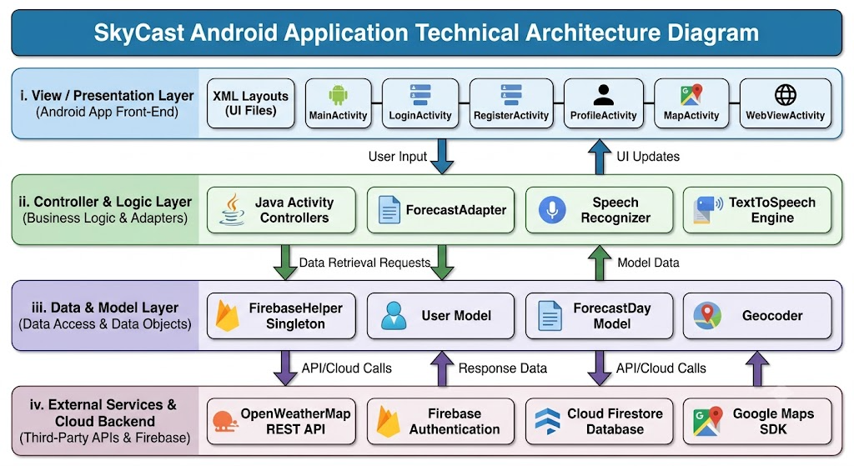

4.2 System Flowchart
Execution Flow:
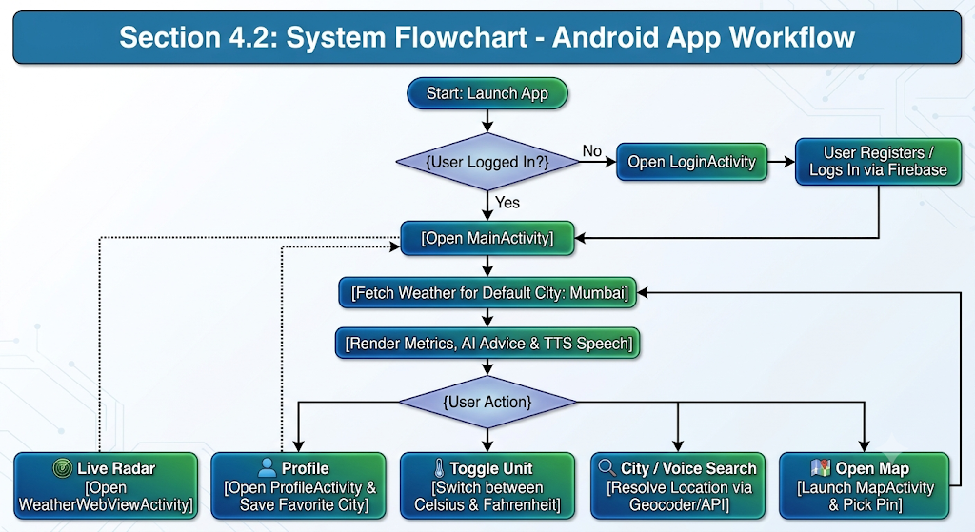

CHAPTER 7: RESULTS AND DISCUSSION
7.1 Screenshots of the Application

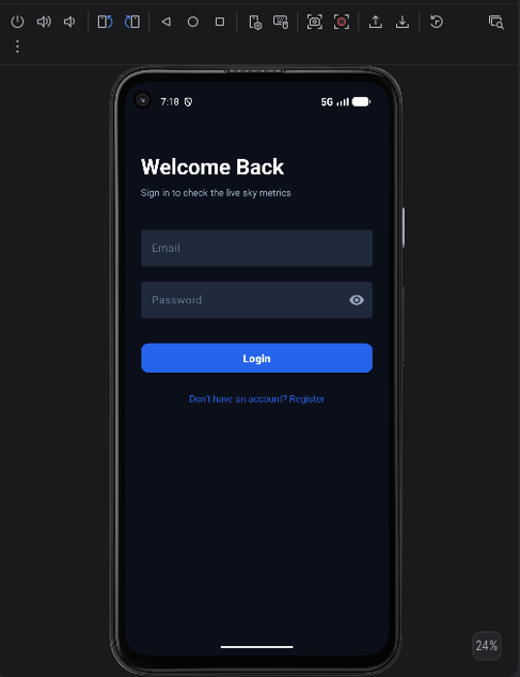
Figure 1. SkyCast login screen displaying the email and password fields.

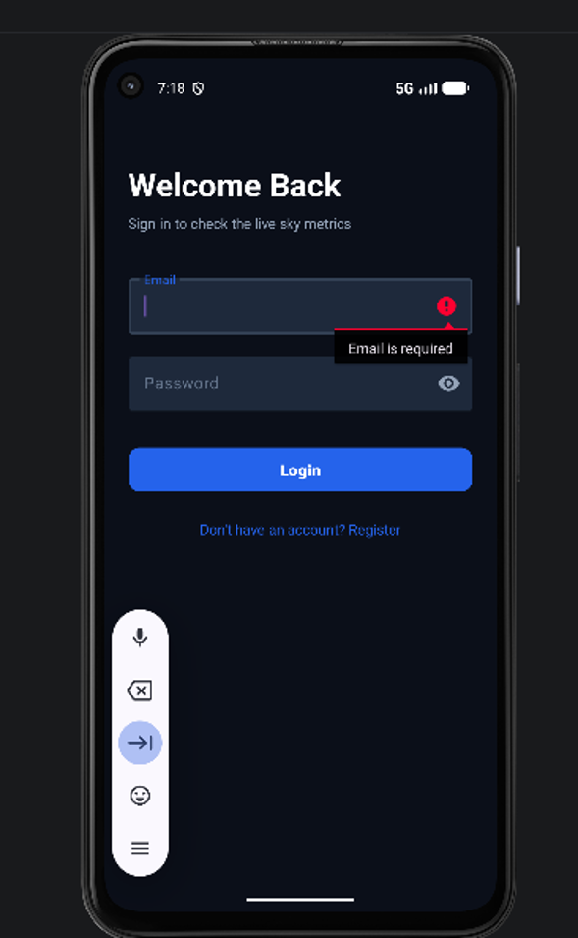
Figure 2. Login form validation indicating that the email field is required.

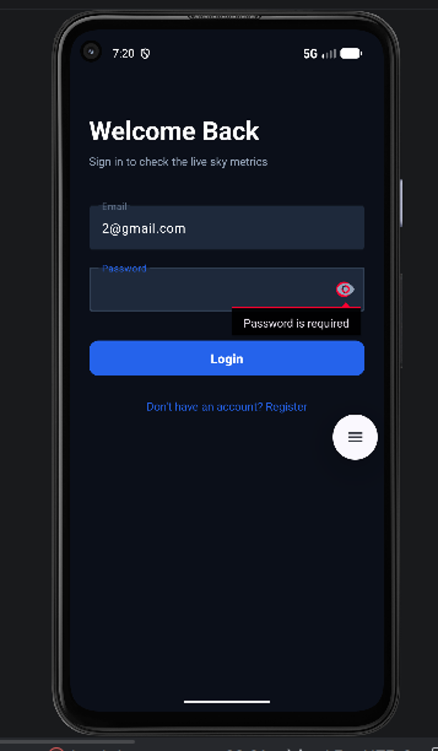
Figure 3. Login form validation indicating that the password field is required.

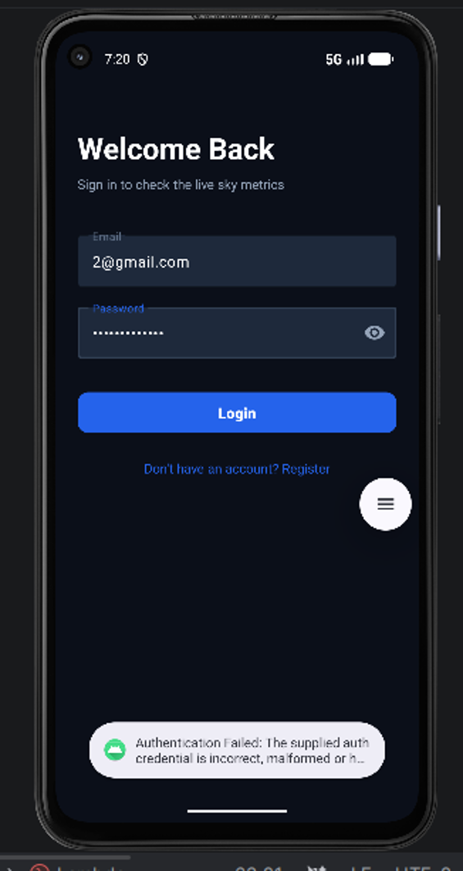
Figure 4. Login attempt showing an authentication failure message.

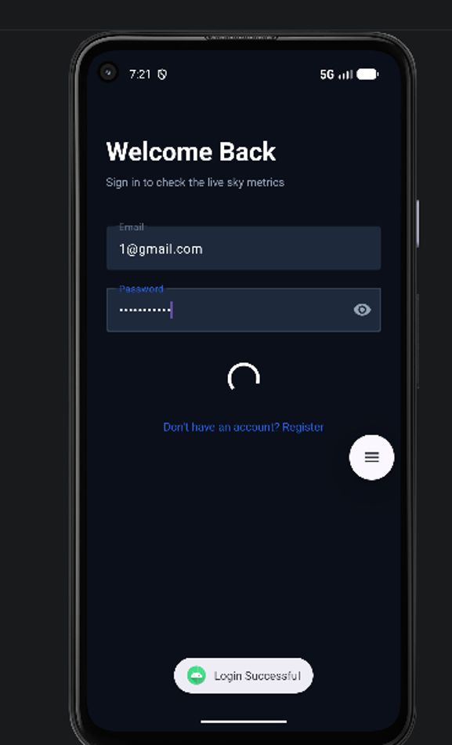
Figure 5. Successful login feedback while the application loads the dashboard.

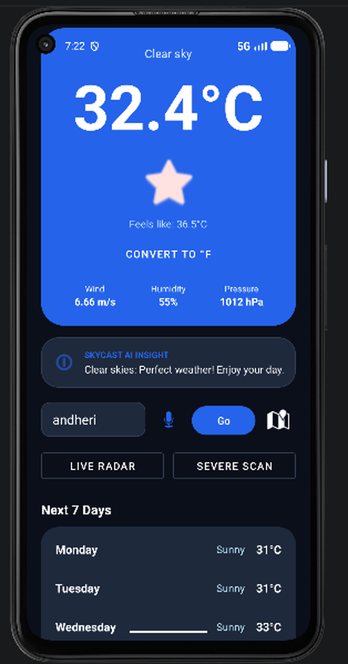
Figure 6. SkyCast weather dashboard showing current temperature and weather metrics in Celsius.

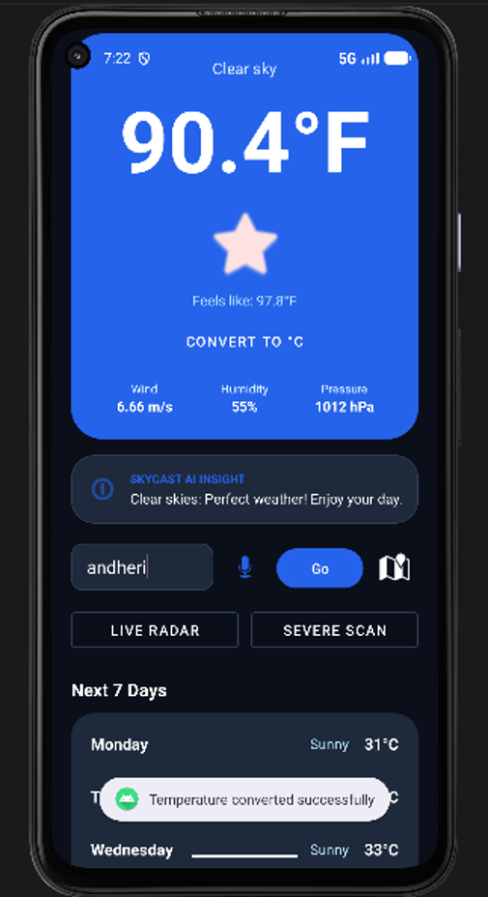
Figure 7. Weather dashboard displaying the temperature in Fahrenheit after conversion.

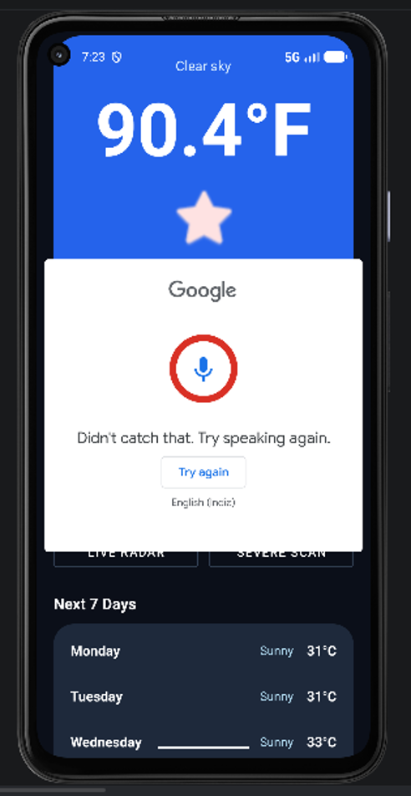
Figure 8. Google voice input dialog opened from the weather search control.
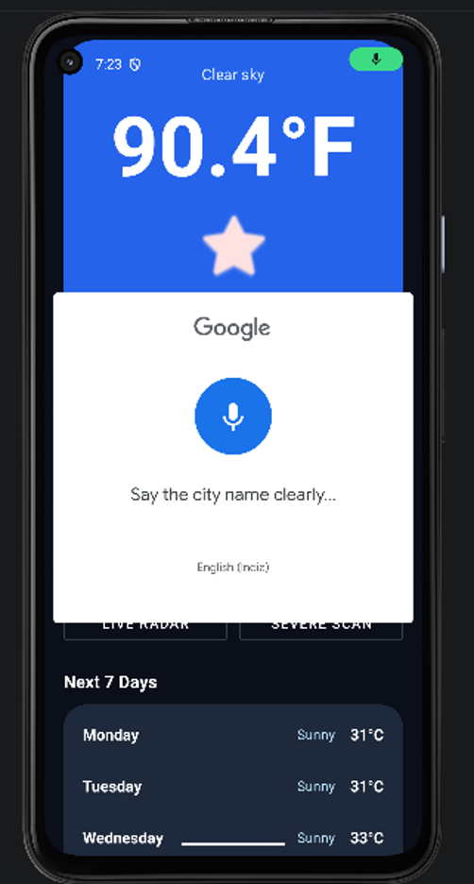
Figure 9. Voice input prompt requesting the user to say a city name.

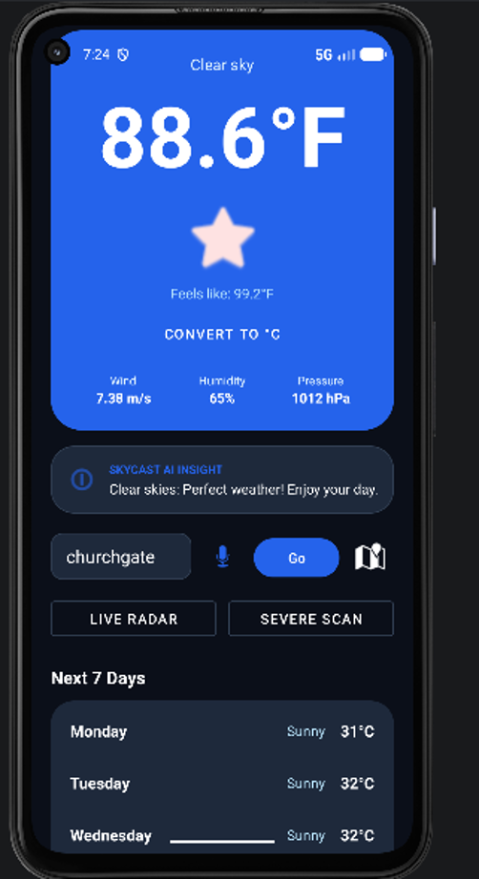
Figure 10. Weather dashboard updated for a different location, Churchgate.

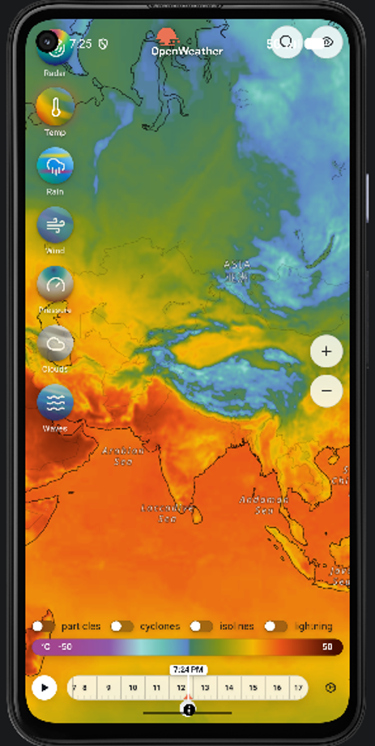
Figure 11. Live weather radar map showing regional weather layers and timeline controls.
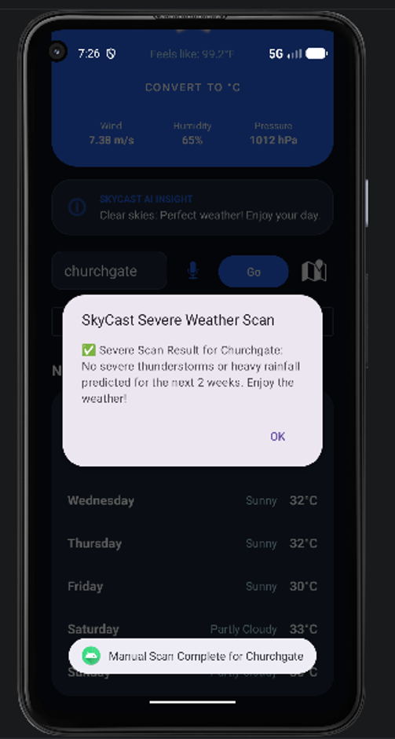
Figure 12. Severe weather scan dialog reporting the scan result for Churchgate.

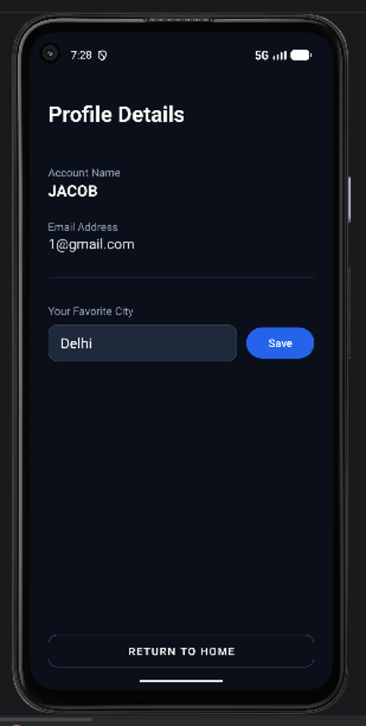
Figure 13. Profile details screen showing account information and the favorite-city field.
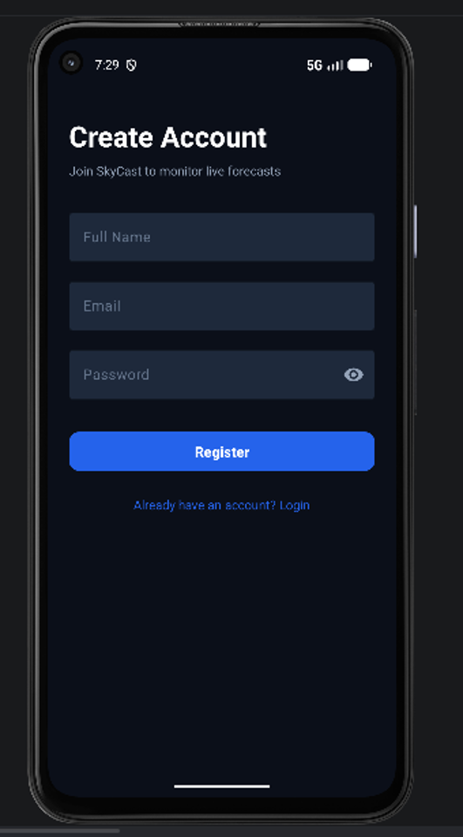
Figure 14. Create Account screen with full name, email, and password fields.

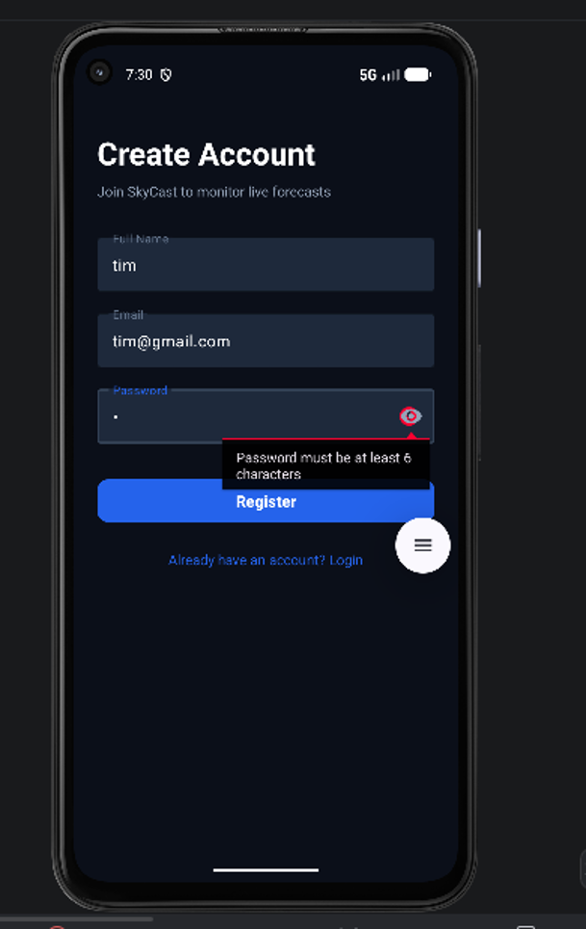
Figure 15. Registration form validation indicating that the password must contain at least six characters.

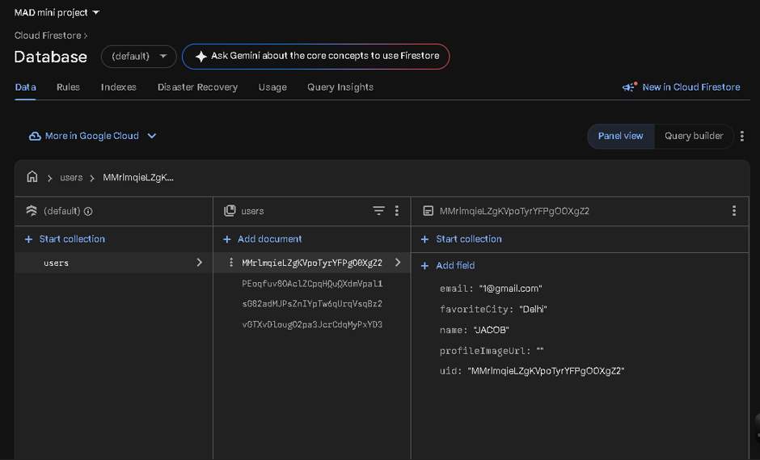
Figure 16. Cloud Firestore users collection displaying a stored user profile document.

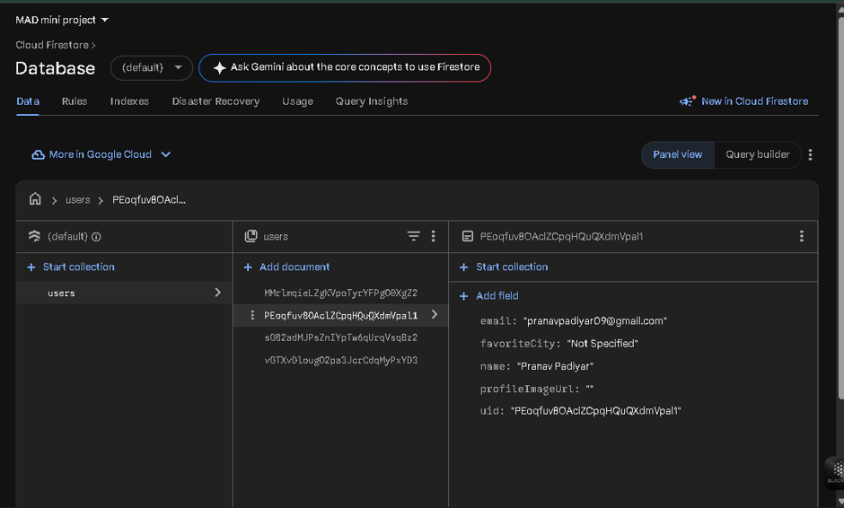
Figure 17. Cloud Firestore displaying another user profile record in the users collection.

7.2 Emulator Execution Results
Testing was conducted on Android Studio Virtual Devices (Pixel 4a , API 35/37).
•Authentication Test: Successfully registers new users and authenticates existing credentials using Firebase Auth.
•REST API Call Test: Successfully returns JSON weather payload for queries like "Mumbai", "London", "Vile Parle, Mumbai", and GPS coordinates.
•Voice Synthesis Test: Verified spoken speech audio output upon weather updates.
•Map Callback Test: Tapping coordinates on MapActivity correctly passes Lat/Lng back via onActivityResult to update weather metrics.

7.3 Physical Device Execution Results
Execution on physical Android handheld hardware verified:
• Speech Recognizer: Microphone permission dialog successfully prompts user; spoken city names (e.g. "Delhi") convert to text accurately and execute weather search.
• Hardware TTS: Hardware speakers produce clear voice readouts.
• Network Resilience: Fast performance over 4G/5G and Wi-Fi connections.

7.4 Limitations of the Project
1. API Rate Limits: Uses OpenWeatherMap free-tier API keys, subject to rate limits per minute.
2. Offline Mode Capability: Requires active internet connection to query live weather metrics and Cloud Firestore.
3. Simulated 7-Day Forecast: 7-day extended forecasts in current build derive from dynamic variation models around real-time conditions rather than multi-day endpoint payloads.

CHAPTER 8: CONCLUSION AND FUTURE SCOPE
Conclusion
The SkyCast Weather Application successfully satisfies all design goals and functional requirements. By integrating cloud technology (Firebase Auth and Firestore), REST APIs (OpenWeatherMap), Google Maps SDK, Geocoding, Android Speech Recognition, and Text-to-Speech synthesis into a modern Java Android architecture, the application delivers a comprehensive, accessible, and user-centric weather forecasting experience.

Future Scope
1. Push Notifications via Firebase Cloud Messaging (FCM): Proactive background alerts for severe weather in the user's favorite city without opening the app all the time.
2. Profile Image : User can see their profile image in the profile section
3. Home Screen Widgets: Custom Android App Widget to display current temperature and AI tips directly on the home launcher without everytime opening the app.
4.Historical Weather Analytics: Graphs and charts showing daily and monthly temperature trends using MPAndroidChart. and past data and safety limits of the place

